Restaurant management system

Sql codes

The tables in the database restaurant:

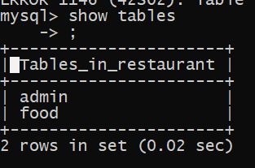

The food table:

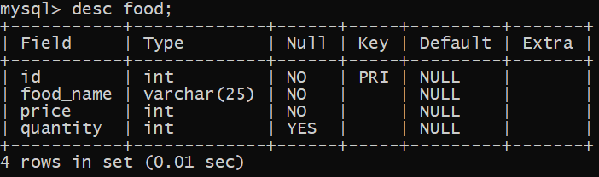

The Admin Table:

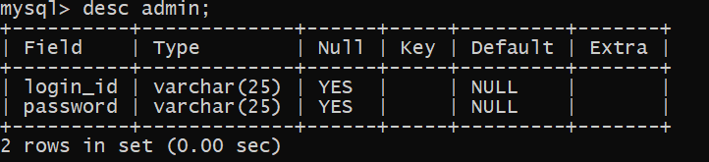

Contents of the Admin table:

